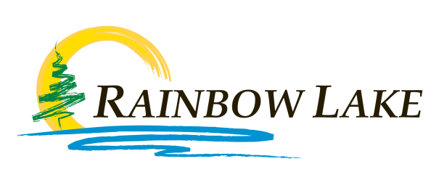
TOWN OF
Box 149
65 Imperial Drive
Rainbow Lake, AB
T0H 2Y0
Ph: 780-956-3934
Fx: 780-956-5613

TOWN OF RAINBOW LAKE RE-ENTRY FREEZER PLAN

- The Town has been without power between May 13th and May 29th.
- Any food items in your refrigerator or freezer are spoiled.
- To assist residents, the Town has organized three fridge and freezer removal crews, beginning on Friday June 2nd, that will come to your home, wrap/tape and remove the fridge and/or freezer out of your home and place it at the end of your driveway on request. Please ensure that the contents of the freezer are frozen (powered for the last 24 hours) so there is no leaking from the unit inside your home during removal.
- Residents will be able to open the unit to take pictures for their insurance for potential reimbursement of the value of the contents.
- If the resident chooses to clean the appliance, you can call the Town once again and we will return the appliance to your home. Instructions have been provided in your re-entry package as well as on www.rainbowlake.ca from Alberta Health Services on how to properly clean your appliance.
- Any removed food contents should be brought to the 30yd bin that will be located at the grocery store parking lot or to the Rainbow Lake Transfer Station so we can get it out of Town quickly and mitigate the wildlife attractiveness.
- If the resident chooses to discard the appliance, you can call the Town once again and we will collect the appliance from your driveway and dispose of it. If you are disposing of the unit then you may leave the appliance full of its contents.
- There will be complications with problem wildlife due to the freezer removal program. All attempts will be made to remove freezer contents quickly and remove them from Town to the landfill near High Level. Please do not simply leave the waste in your driveway. If you are unable to take the waste products to the designated drop-off points, please let the Town know so we can plan to remove that waste and keep the bears out as much as possible.

To be added to the list of residences requesting fridge/freezer removal please send an email to admin@rainbowlake.ca or call 780-956-3934. Please be patient as we have many houses requesting this service. We will make every effort to get to your home as quickly as possible. As there will be a limited number of people available on the phone, sending an email is preferred.

